Md Nasif Uddin

Batch : 20

Date : 05 oct. 2024



An Overview of Gadget Home Ltd.

Contents

1.executive Summary 2

1.1 Company Overview 2

1.2 Mission and Vision 2

1.3 Core Values 2

2. Products of Gadget Home Ltd. 3

2.1 Products and Services 3

3.Flowchart of Business Plan 5

3.1 Statistics of sold products in last 3 months (January -March 2024) 6

3.2 Sales report of Gadget Home Ltd. (January – March,2024) 6

3.3 Yearly report of Gadget Home Ltd. 7

4. Market Positions 8

5. Challenges and Opportunities 8

6. Conclusion 8

# 1.executive Summary

## 1.1 Company Overview

Gadget Home Ltd. is a premier technology-driven manufacturing firm based in Bangladesh. Established in 2010, the company has rapidly evolved into a key player in the electronics and consumer goods sectors, specializing in the production of high-quality electronic components, home appliances, and consumer electronics

## 1.2 Mission and Vision

* **Mission:** To deliver innovative and superior quality products that enhance the everyday lives of consumers while fostering sustainable growth and development.
* **Vision:** To be a global leader in the manufacturing industry, known for our commitment to excellence, innovation, and environmental stewardship

## 1.3 Core Values

* **Quality:** Adhering to the highest standards in every aspect of our operations.
* **Innovation:** Continuously seeking new ways to improve our products and processes.
* **Sustainability:** Minimizing our environmental footprint through responsible practices.
* **Customer Focus:** Prioritizing customer satisfaction through exceptional service and product reliability.
* **Integrity:** Conducting business with transparency and ethical practices.

# 2. Products of Gadget Home Ltd.

## 2.1 Products and Services

Gadget Home Ltd. offers a diverse range of products including:

* **Electronic Components:** Precision-engineered components for various industrial applications.
* 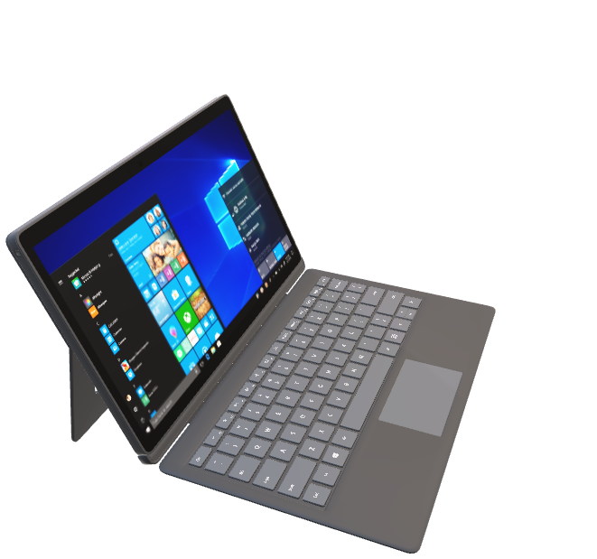**Home Appliances:** High-efficiency refrigerators, washing machines, and air conditioners.
* **Consumer Electronics:** Cutting-edge smartphones, tablets, and smart home devices.

Laptpos

Known for their blend of performance, portability, and affordability, Gadget home’s laptops feature sleek designs, robust build quality, the latest processors, and high-definition displays, catering to a wide range of users from students to professionals.

**Desktops**

**Tablets**

**Smartphones**

# 3.Flowchart of Business Plan

**Gadget Home Ltd**

## 3.1 Statistics of sold products in last 3 months (January -March 2024)

|  |  |
| --- | --- |
| **The sum of Total Sales (BDT)** |  |
| **Product** | **Total** |
| Desktop | 6950000 |
| Laptop | 12250000 |
| Smartphone | 6150000 |
| Tablet | 3320000 |
| **Grand Total** | **28670000** |

|  |  |
| --- | --- |
| **The sum of Total Sales (BDT)** | |
| **Months (Date)** | **Total** |
| Jan | 8750000 |
| Feb | 9920000 |
| Mar | 10000000 |
| **Grand Total** | **28670000** |

## 3.2 Sales report of Gadget Home Ltd. (January – March,2024)

## 3.3 Yearly report of Gadget Home Ltd.

|  |  |  |  |
| --- | --- | --- | --- |
| **Yearly report** | | | |
| Month | Expenses | Sales | Profit |
| January | 9288500 | 8750000 | -538500 |
| February | 9744300 | 9920000 | 175700 |
| March | 8904700 | 10000000 | 1095300 |
| April | 7345200 | 7957400 | 612200 |
| May | 8987000 | 9876500 | 889500 |
| June | 5215400 | 5164500 | -50900 |
| July | 9976500 | 11543600 | 1567100 |
| August | 7976700 | 8087900 | 111200 |
| September | 9879000 | 9969800 | 90800 |
| October | 6234800 | 7024000 | 789200 |
| November | 4534800 | 4809300 | 274500 |
| December | 8348700 | 8834800 | 486100 |

# 4. Market Positions

With a strong domestic market presence, Gadget Home Ltd. is also expanding its footprint internationally. The company’s strategic partnerships and robust supply chain have enabled it to compete effectively in the global market.

# 5. Challenges and Opportunities

* **Challenges:** Navigating global supply chain disruptions and increasing competition from international brands.
* **Opportunities:** Capitalizing on the growing demand for eco-friendly products and leveraging digital transformation to streamline operations.

# 6. Conclusion

Gadget Home Ltd. is committed to driving progress and delivering value to its stakeholders. With a clear vision, robust strategy, and unwavering dedication to excellence, the company is well-equipped to achieve its long-term objectives and sustain its competitive advantage in the global market.

Thank you.